25.4 Editors - Properties Editor - View Layer Properties Tab
View Layer 3
View Layer Panel - All Renderers 3
View Layer Prop 3
View Layer list 3
View Layer edit box 3
Add View Layer 3
New 4
Copy Settings 4
Blank 4
Remove View Layer 4
Use for Rendering 4
Animate Property 4
Render Single Layer 4
Eevee - Passes 4
Data 4
Combined 4
Z 4
Mist 4
Normal 5
Light 5
Diffuse 5
Light 5
Color 5
Specular 5
Light 5
Color 5
Volume 5
Transmittance 5
Scatter 5
Other 5
Emission 5
Environment 5
Shadow 5
Ambient Occlusion 5
Effects 6
Cycles - Passes Panel 6
Data 6
Include 6
Combined 6
Z 6
Mist 6
Normal 6
Vector 6
UV 6
Denoising Data 6
Indexes 6
Object Index 6
Material Index 6
Debug 7
Render Time 7
Sample Count 7
Alpha Threshold 7
Light 7
Diffuse 7
Direct 7
Indirect 7
Color 7
Glossy 7
Direct 7
Indirect 7
Color 7
Transmission 8
Direct 8
Indirect 8
Color 8
Volume 8
Direct 8
Indirect 8
Color 8
Other 8
Emission 8
Environment 8
Shadow 8
Ambient Occlusion 8
Cryptomatte 8
Include 9
Object 9
Materials 9
Asset 9
Levels 9
Accurate Mode 9
Cycles - Filter Panel 9
Include 9
Environment 9
Ambient Occlusion 9
Surfaces 9
Hair 9
Volume 9
Freestyle 9
Cycles - Override Panel 10
Material Override 10
Samples 10

View Layer

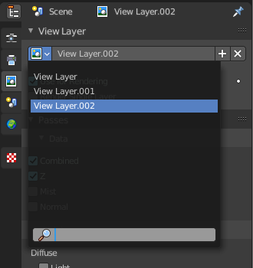
View Layers reference to Scene collections. They allow to set their visibility, selectability and other options. Each View Layer can use any collection you wish, and multiple View Layers can use the same collections or different collections.
Usually you have just one View layer for the whole scene. But you can create more View layers in the header, and rename them there.

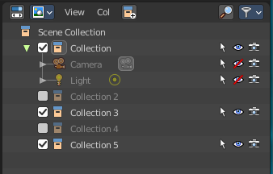
View layers are by default active for all collections. You can exclude them for specific layers in the Outliner. Select the view layer, and turn off the collections that you don't want to have active in this view layer.

Note. The different render engines uses different view layer functionality. And so the panels and available options differs.

View Layer Panel - All Renderers

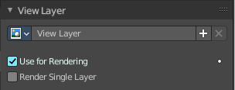
View Layer Prop

View Layer list
The list of available view layers

View Layer edit box
Set the active view layer, and view and edit the name of the current active view layer. Click into the edit box to edit the name.

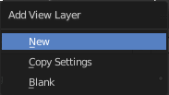
Add View Layer
Adds a new view layer.

New
Adds a new view layer with the default content.

Copy Settings
Adds a new view layer with the content of the current active layer.

Blank
Adds a new view layer and deactivates all collections.

Remove View Layer
Removes the selected view layer.

Use for Rendering
Disable or enable the render layer.

Animate Property
This property can be animated. Activating this button sets a keyframe at the current frame.

Render Single Layer
Only render the active layer. This just works for rendering from the interface. Rendering from command line ignores this setting.

Eevee - Passes

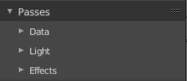
Here you enable or disable passes for single features.

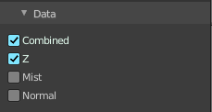
Data

Combined
Deliver full combined RGBA Buffer.

Z
Deliver Z Value pass.

Mist
Deliver Mist factor pass. 0.0 to 1.0

Normal
Deliver Normal pass.

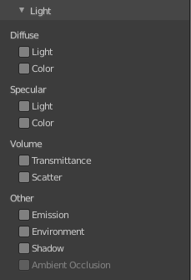
Light

Diffuse

Light
Deliver diffuse direct pass.

Color
Deliver diffuse color pass.

Specular

Light
Deliver specular direct pass.

Color
Deliver specular color pass.

Volume

Transmittance
Deliver volume transmittance pass.

Scatter
Deliver volume scattering pass.

Other

Emission
Deliver emission pass.

Environment
Deliver environment lighting pass.

Shadow
Deliver shadow pass.

Ambient Occlusion
Deliver Ambient Occlusion pass. Ambient Occlusion needs to be enabled in the Render Properties.

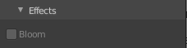
Effects
Deliver Bloom pass. Bloom must be enabled in the Render Properties.

Cycles - Passes Panel
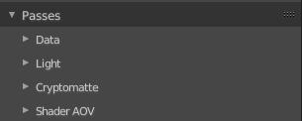

Here you enable or disable passes for single features.

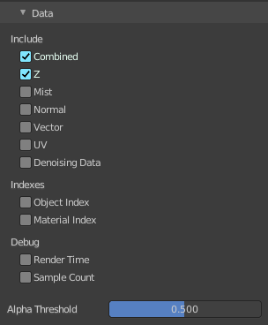
Data

Include

Combined
Deliver full combined RGBA Buffer.

Z
Deliver Z Value pass.

Mist
Deliver Mist factor pass. 0.0 - 1.0.

Normal
Deliver Normal pass.

Vector
Deliver Speed Vector pass.

UV
Deliver UV pass.

Denoising Data
Store the denoising feature passes and the noisy image.

Indexes

Object Index
Deliver Object Index pass.

Material Index
Deliver Material Index pass.

Debug

Render Time
Render time in milliseconds per sample and pixel.

Sample Count
Number of samples/camera rays per pixel.

Alpha Threshold
Z, Index, Normal, UV and Vector passes are just affected by surfaces with alpha transparency equal or higher this threshold.

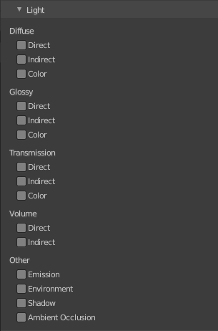
Light

Diffuse

Direct
Deliver direct pass.

Indirect
Deliver indirect pass.

Color
Deliver color pass.

Glossy

Direct
Deliver direct pass.

Indirect
Deliver indirect pass.

Color
Deliver color pass.

Transmission

Direct
Deliver direct pass.

Indirect
Deliver indirect pass.

Color
Deliver color pass.

Volume

Direct
Deliver direct pass.

Indirect
Deliver indirect pass.

Color
Deliver color pass.

Other

Emission
Deliver Emission pass.

Environment
Deliver Environment pass.

Shadow
Deliver Shadow pass.

Ambient Occlusion
Deliver Ambient Occlusion pass.

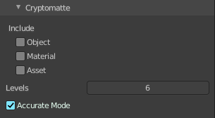
Cryptomatte
Cryptomatte passes can be used to isolate objects or materials or assets in compositing.

Include

Object
Render Cryptomatte Object Pass.

Materials
Render Cryptomatte Materials Pass.

Asset
Render Cryptomatte Asset Pass.

Levels
How many unique objects can be distinguished per pixel

Accurate Mode
Generate a more accurate cryptomatte pass. This feature renders at the CPU only, and consumes more memory.

Cycles - Filter Panel

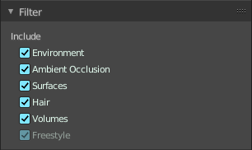
Include

Environment
Render Sky in this layer.

Ambient Occlusion
Render Ambient Occlusion in this layer.

Surfaces
Render solid surfaces in this layer.

Hair
Render Hair in this layer.

Volume
Render volumes in this layer.

Freestyle
Render stylized strokes in this layer. This feature is greyed out when Freestyle is not activated.

Cycles - Override Panel
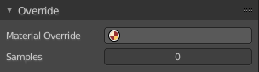
Here you can add a material that overrides all other materials in this layer. This allows clay renderings.

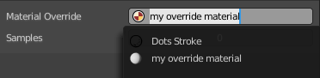
Material Override
Pick a material in the scene that should override all other materials.

Samples
Override number of render samples for this view layer. A value of 0 will use the scene setting values.

